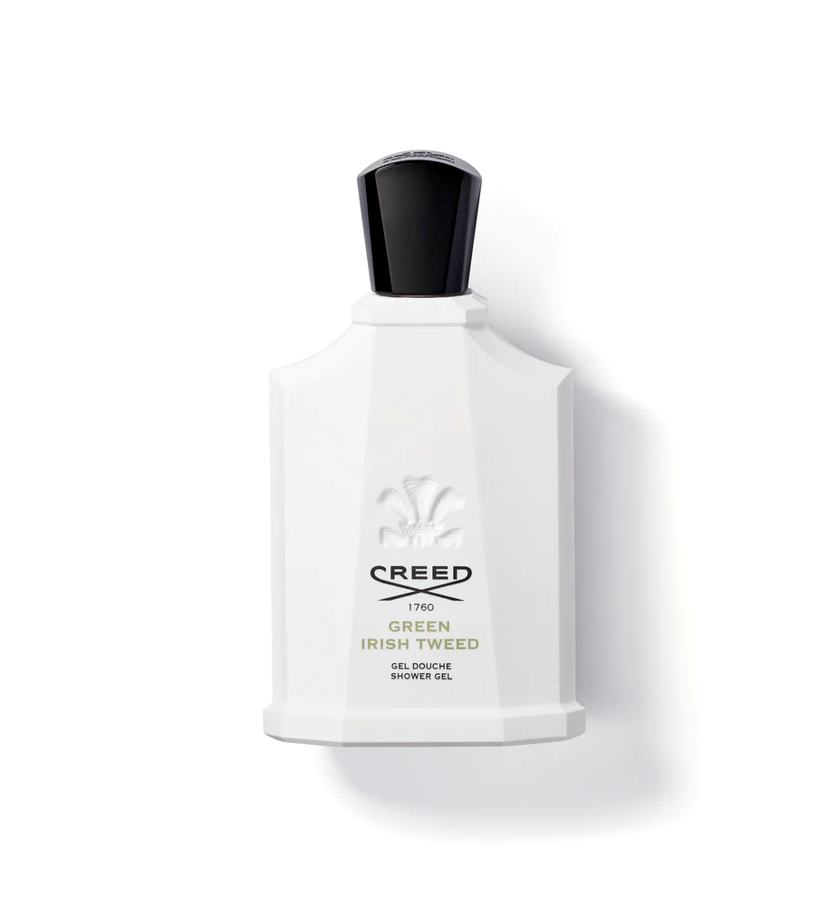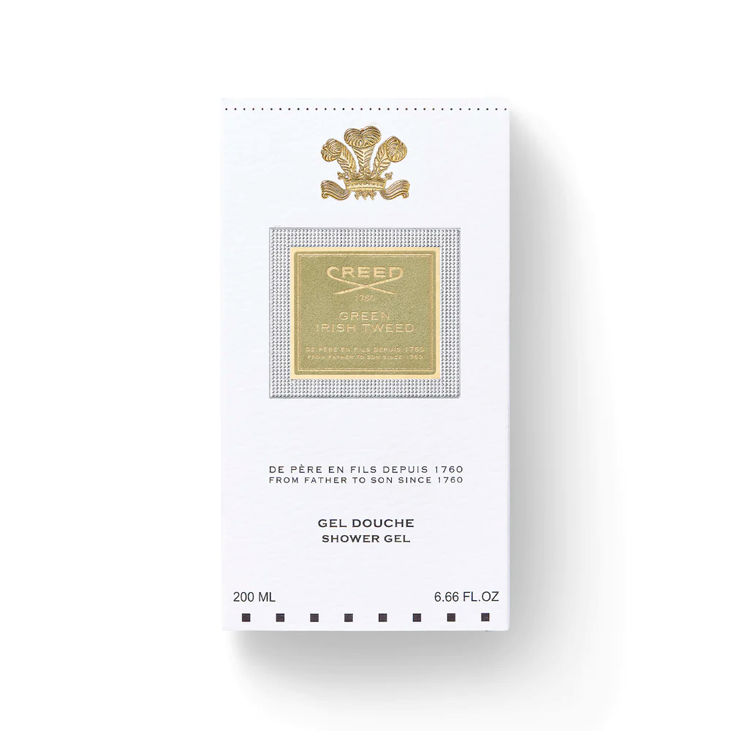

**CREED SILVER MOUNTAIN WATER**

$470.00

Tax Included.

Spray 100 mL

IN STOCK

### Product Details

A bestseller since its launch, this modern marine/green scent captures the purity of the mountains-soft, milky-sweet blackcurrants mixed with green tea, the richness of bergamot, and sandalwood.

Its opaque white bottle hints at icy snowbanks topped with a glistening cap.